Outdoor Learning Centre
Address
Postcode
Council Area
Main Telephone

Youth Service
Outdoor Learning Service Risk Assessment
(Covid-19)
(Including Outreach & Detached)

July 2020

LIST OF ASSESSED RISKS
Spread of Covid-19 through the Delivery of Outdoor Learning provision and out into wider community 5
Suspected or confirmed case of a participant who takes part in and Outdoor Learning service programme 7
Shortage of staff, Absence of Centre Leadership 8
Providing emergency assistance/ first aid required 9
Exposure to contaminated equipment and specialist activity clothing 10
Use of Transport 11
Unmanaged interaction with public and /or public environments 12
(Building Cleaning & Maintenance) Potential exposure to Covid-19 whilst cleaning 13
(Building Cleaning & Maintenance) Risk of exposure to Covid-19 due to symptomatic or confirmed cases within location 14
(Building Cleaning & Maintenance) Risk of exposure to Covid-19 whilst preparing Centre for September during the months of July and August 15

Sign off and Approval
Completed By
Approval

Risk Assessment Matrix
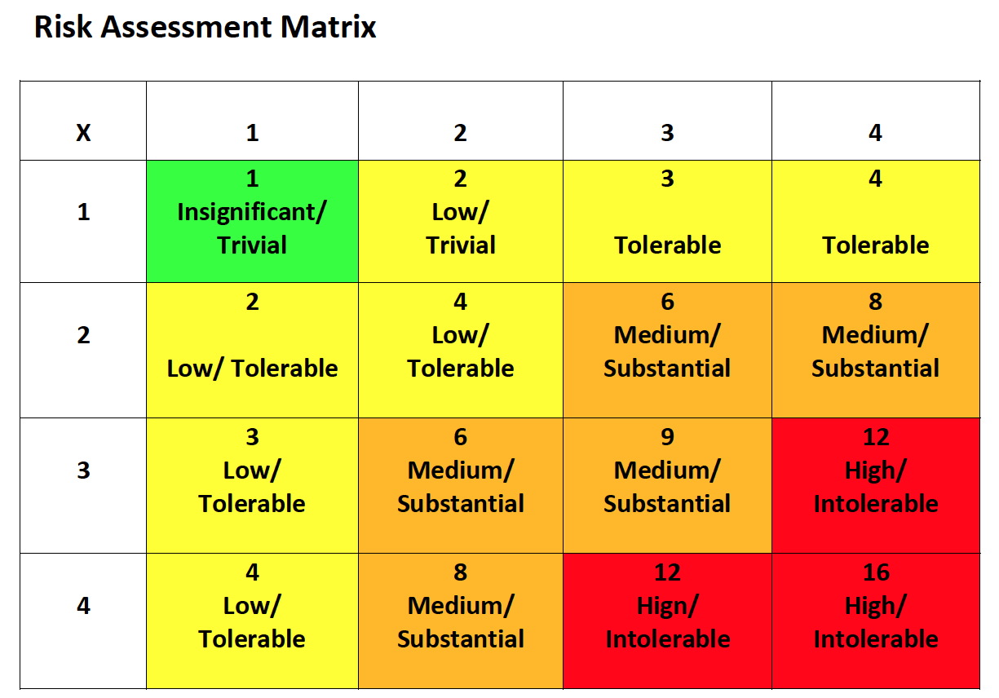

Completed by: Date: Review Date: Ongoing
Hazard | To Whom | Severity | Likelihood | Risk
Spread of Covid-19 through the Delivery of Outdoor Learning provision and out into wider community | Children & Young People | 1 | 3 | 3
 | Youth Staff (including School staff) | 3 | 3 | 9
 | Wider Community | 3 | 2 | 6
Existing Precautions |  | Additional Precautions | Who | When
- Hand-over of children young people youth centre and collection of children and young people at end of the session is structured to maintain social distancing of at least 2 metres. Parents/carers/youth workers are instructed not to enter the centre building. Children and young people are received into centre by a member of staff, maintaining social distancing protocols. Structured release of children and young people at the end of the session. https://www.education-ni.gov.uk/publications/implementing-social-distancing-education-settings-ni-coronavirus-covid-19
- Communication sent to all group leaders that should their young person appear unwell they should not be sent to Youth Provision.
- Group Leaders informed by letter that they are not to congregate at centre gates, entrances or within the outdoor spaces upon arrival and departure
- Soap dispenser and paper towels/hand driers within toilets are fully stocked at the start of each day. Regular checks to be made throughout the day to ensure adequate supply.
- Handwashing techniques taught to all young people. It may be necessary to supervise some young people to ensure correct hand washing procedures.

Hazard
Spread of Covid-19 through School Based Youth Work provision and out into wider community (Cont.)
Existing Precautions | Additional Precautions | Who | When
- Inform group leaders of hygiene expectations and for the need to communicate this message in the home environment.
- All staff/young people to wash their hands before coming to the centre, during the session, before going home and when they get home.
- Information sessions to demonstrate to children and young people appropriate hand washing techniques.
- Food or drinks will not be provided by outdoor learning service whilst PHA guidance is in place.
- Staff and groups leaders monitor the visible health of young people, ensure parent emergency contact numbers are kept up to date.
- Public Health Advice on Covid-19 handwashing – Catch it, Bin it, Kill it posters around youth provision
- Hand sanitiser provided to youth provision for staff.
- Communicate to parents the importance of the government advice on catch it, bin it kill it.
- Keep all internal room and corridor doors propped open.
- Safety Agreement to be established with all young people relating to PHA guidance and adhering to social distancing measures. Parents to be informed of the agreement and any action which could be taken if this is not followed.
- Group leader details are to be recorded for each activity on a daily basis providing date of visit, name of group and group leader.
Completed by: Date: Review Date: Ongoing
Hazard | To Whom | Severity | Likelihood | Risk
Suspected or confirmed case of a participant who takes part in and Outdoor Learning service programme | Children and young people | 1 | 3 | 3
 | Staff | 3 | 3 | 9
 | Wider community | 3 | 2 | 6
Existing Precautions |  | Additional Precautions | Who | When
- Contact relevant agencies e.g. PHA, EA, etc.
- Close provision for a period of 72 hours where the member of staff or young person has only had restricted access to that area. If person displaying the symptoms had access to a number of rooms other than for transit purposes, then all areas accessed should be isolated for 72 hours. Cleaning to be completed after 72 hours and before reoccupation of the centre.
- In the case where the staff or young person may have spent their time in a number of rooms, all rooms should be closed.
- Inform staff.
- Contact relevant groups leaders with EA Communications support
- Refer to Education Minster’s advice dated 16 March 2020 on what to do if someone develops symptoms of Covid-19 in a school or other educational setting.
- Youth Service must not name individuals.
Completed by: Date: Review Date: Ongoing
Hazard | To Whom | Severity | Likelihood | Risk
Shortage of staff, Absence of Centre Leadership | Children & Young People | 2 | 3 | 6
Existing Precautions |  | Additional Precautions | Who | When
- Redeploy staff from a nearby location
- Consider combining provision whilst maintaining social distancing.
- Where Worker/Young person ratios exceed DE recommendations – partial closure for certain programmes.
- Alert groups leaders.
- Notify EA/DE in the event of an exceptional closures.
Completed by: Date: Review Date: Ongoing
Hazard | To Whom | Severity | Likelihood | Risk
Providing emergency assistance/ first aid required | Children and young people | 1 | 3 | 3
 | Staff | 3 | 3 | 9
 | Wider community | 3 | 2 | 6
Existing Precautions |  | Additional Precautions | Who | When
- Provision of appropriate PPE to staff in line with health care / paramedic standard.
- Limit activity to sites where trained and equipped emergency services can access in reasonable time.
- Adherence to advice from the DE guidance for safe working practices in education settings.
Completed by: Date: Review Date: Ongoing
Hazard | To Whom | Severity | Likelihood | Risk
Exposure to contaminated equipment and specialist activity clothing | Children and young people | 1 | 3 | 3
 | Staff | 3 | 3 | 9
 | Wider community | 3 | 2 | 6
Existing Precautions |  | Additional Precautions | Who | When
- Equipment sluiced in recommended sanitising solution following use where manufacturers direction allows
- Soap wash for garments
- Passive air drying outside. Remove forced drying to reduce airborne contamination
- System of 72 hour quarantine for equipment post activity.
- Issued equipment managed by single user
- Staff managing equipment post activity wear PPE and/or diligent handwashing
Completed by: Date: Review Date: Ongoing
Hazard | To Whom | Severity | Likelihood | Risk
Use of Transport | Children and young people | 1 | 3 | 3
 | Staff | 3 | 3 | 9
 | Wider community | 3 | 2 | 6
Existing Precautions |  | Additional Precautions | Who | When
- Limit number of vehicle occupants PHA/EA guidance (e.g. 17 seater minibus a Max of 2 persons based on the 2 metres social distancing and 3 persons based on the 1 metre social distancing – these figures include the driver).
- Mark seats that cannot be used by participants
- Provide opportunity to sanitise hands entering and exiting vehicle
- Disinfection vehicle interior using recommended products when the existing group has completed use, no other groups or young people can use this vehicle until this happens
- Avoid use of forced air ventilation/air con. Favour open windows

Completed by: Date: Review Date: Ongoing
Hazard | To Whom | Severity | Likelihood | Risk
Unmanaged interaction with public and /or public environments | Children and young people | 1 | 3 | 3
 | Staff | 3 | 3 | 9
 | Wider community | 3 | 2 | 6
Existing Precautions |  | Additional Precautions | Who | When
- Avoid venues and time periods where young people will be drawn into a situation where they could potential breach social distancing guidance.
- Favour well definable activity area with agreed/exclusive access.
- Demonstrate active social distancing and attention to hand sanitation protocols in public areas.
Completed by: Date: Review Date: Ongoing
Hazard | To Whom | Severity | Likelihood | Risk
(Building Cleaning & Maintenance) Potential exposure to Covid-19 whilst cleaning | Children and young people | 1 | 3 | 3
 | Cleaning and youth work Staff | 3 | 3 | 9
 | Centre visitors and Wider community | 3 | 2 | 6
Existing Precautions |  | Additional Precautions | Who | When
- Adhere to PHA guidance for handwashing
- Appropriate PPE worn; disposable gloves and aprons used for all activities that may result in contamination, uniform, flat closed in shoes, hand sanitiser
- HSC Public Health Agency Guidance on Covid-19 displayed in school and referred to as necessary
- All touch/contact areas cleaned with germicidal disinfectant e.g. Shield/Protect
- Social Distancing measures in place
- Minimal number of cleaning staff working on a rotation basis.
- Where possible cleaning staff commence work when least number of people within the building
- Cleaning staff maintain social distance of at least 2 metres at all times
Completed by: Date: Review Date: Ongoing
Hazard | To Whom | Severity | Likelihood | Risk
(Building Cleaning & Maintenance) Risk of exposure to Covid-19 due to symptomatic or confirmed cases within location | Children and young people | 1 | 3 | 3
 | Cleaning and youth work Staff | 3 | 3 | 9
 | Centre visitors and Wider community | 3 | 2 | 6
Existing Precautions |  | Additional Precautions | Who | When
- Location closed for 72 hours
- Area closed for 72 hours
- After 72 hours cleaning staff complete an enhanced clean of area following normal system of clean with additional focus on touch/contact areas before the return of staff and children
- Apron, gloves or any contaminated items double bagged and disposed of appropriately after a single use
Completed by: Date: Review Date: Ongoing
Hazard | To Whom | Severity | Likelihood | Risk
(Building Cleaning & Maintenance) Risk of exposure to Covid-19 whilst preparing Centre for September during the months of July and August | Children and young people | 1 | 3 | 3
 | Cleaning and youth work Staff | 3 | 3 | 9
 | Centre visitors and Wider community | 3 | 2 | 6
Existing Precautions |  | Additional Precautions | Who | When
- Adhere to PHA guidance for handwashing
- Appropriate PPE worn; disposable gloves and aprons used for all activities that may result in contamination, uniform, flat closed in shoes, hand sanitiser
- HSC Public Health Agency Guidance on Covid-19 displayed in Centre and referred to as necessary
- All touch/contact areas cleaned with germicidal disinfectant e.g. Shield/Protect
- Social Distancing measures in place
- Cleaning staff have designated cleaning area
- Where possible cleaning staff commence work when least number of people within the building
- Cleaning staff maintain social distance of at least 2 metres at all times
- Cleaning staff do not undertake duties which have the need for 2 people, i.e. lifting of tables from rooms

